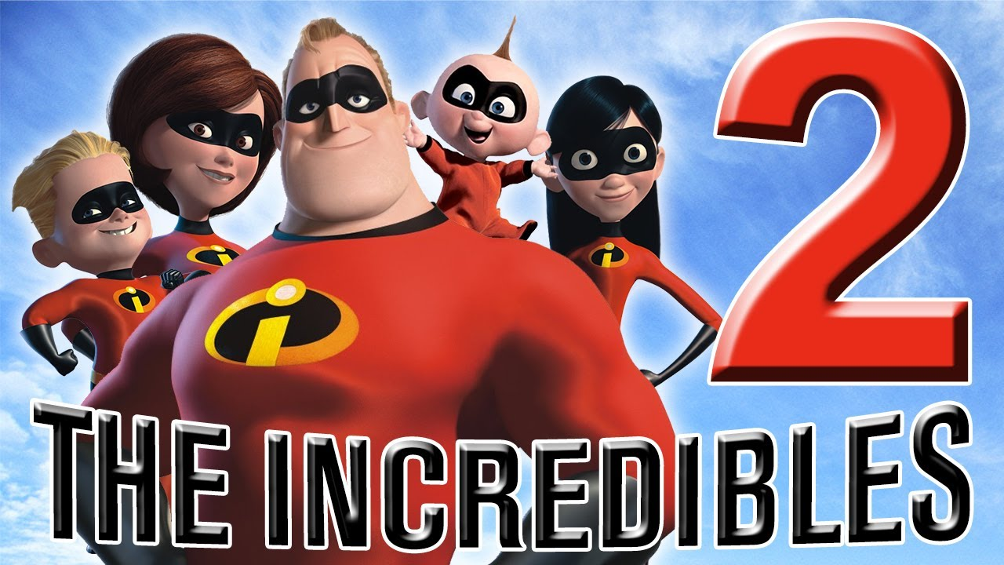
Showing: The Incredibles 2
Student Council Movie Night
Stillwater Elementary Gym
Friday, November 16th, 5:30-8:00 P.M.

Dinner: NEW this year, we have pizza meals available to purchase via the prepaid meal order form below. Order by Tuesday, November 13th to receive the pre-order discount. The cost for a pizza meal at the door will increase in price to $7 and only be available while supplies last, so we recommend pre-ordering.
Concession Stand: In addition to our pizza meals, we will have a concession stand with popcorn, candy bars, water, soda and chips.

Raffle: We are excited to also be offering a raffle as a FUNdraiser for Student Council!! There will be a movie themed raffle basket AND a Movie Night Party Package* available to win. Raffle tickets will be $2 for 1 ticket or 6 tickets for $10. *For the Movie Night Party Package, the winning family will get to invite up to 30 students to come watch a movie in the gym, popcorn provided. The winning family will need to work with student council leadership and the school to find a date that works for all and when the gym is free, please note the gym is busiest between October and March for basketball.

Entry: The suggested entry donation is one non-perishable food item per person benefiting Holy Innocents Food Pantry. Some canned food items they request: fruit, tomato sauce, chicken/tuna, meat, chili, hearty soups, pasta sauce. Other food items they request: cereal, peanut butter, jelly, salad dressing, ketchup, mustard, sugar and ground coffee.

Seating: Please bring a pillow, blanket or concert chair to make yourself comfortable on the gym floor!

-----------------------------------------Prepaid Meal Order Form – Detach Here----------------------------------------

Student Council Movie Night Prepaid Meal Order Form
MUST ORDER BY: Tuesday, NOVEMBER 13th

Items  Pizza Meal Includes: 2 Slices of Pizza and a Water Bottle. | Pre-Order Price | Quantity | Total  Due
Cheese Pizza | $6.00
Pepperoni Pizza | $6.00
Gluten Free Pepperoni Pizza | $6.00
Grand Total:

Payment: Cash Check #___________ (Checks payable to “Stillwater Elementary”)

Your Name (Please Print): _________________________________________________________________

Child/Children Name(s): ________________________________________________________

Teacher Name(s): _________________________________________________________________

E-mail (in case we have questions about the order): _________________________________________________________________

Please send this order form and payment with your child in an envelope marked Movie Night by November 13th. Prepaid meal tickets can be picked up at “Will Call” outside the Stillwater gym starting at 5:30 P.M. Cash/Check will be accepted at all stations the night of the event. To request confirmation of payment or if you have questions, please email Danielle Peters and Laura Liljegren at petersd@rsd407.org and liljegrenl@rsd407.org.

