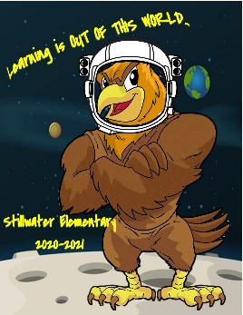
December
2nd – CobraPie Pie Eating Contest
4th-18th – Holiday Food Drive
15th-27th – Ugly Sweater Contest
17th – PTSA Board Meeting
21st-Jan.1st - NO SCHOOL (Winter Break)
January
12th – PTSA Board Meeting
18th – MLK Day – NO SCHOOL
29th – Teacher Day – NO SCHOOL

September
1st – First Day of School!! Go Hawks!
7th – Labor Day – NO SCHOOL
11th – Supply Drop off/Pick up starts
15th - Virtual Curriculum Night
30th – PTSA General Meeting 6:30pm
October
6th – PTSA Board Meeting
9th – Teacher Day – NO SCHOOL
1st-25th – PTSA Pumpkin Carving Challenge
May
3rd-7th – SAW Week
11th – PTSA Board Meeting
31st – Memorial Day – NO SCHOOL

TBD – Moms & Me

June
8th – PTSA Board Meeting
9th – PTSA General Meeting 6:30pm
15th -Last Day of School
TBD – Dads and Donuts
March
1st-15th – Brown Bear Fundraiser
8th-11th – Spirit Week
9th – PTSA Board Meeting
12th – Teacher Day – NO SCHOOL
13th – Playground Install
23rd – Talent Show Submissions Due

29th-April 5th – Egg Decorating Contest
February
1st -6th – Lego Week
3rd – PTSA General Meeting 6:30pm
5th and 6th – Krispy Kreme Fundraiser
11th – PTSA Board Meeting
12th-15th - NO SCHOOL (Midwinter)

April
5th – Egg Entries Due
8th – PTSA Board Meeting
12th-16th - NO SCHOOL (Spring Break)
21st – PTSA General Meeting 6:30pm
23rd – Yearbook Orders Due
26th-30th – Sports Week
TBD – Spring Bingo
Denotes a PTSA Board of Directors Meeting, you can request to be a guest by e-mailing president@stillwaterptsa.org
Denotes a non PTSA Event

November
5th – Reflections Deadline
10th – PTSA Board Meeting
10th-24th – Disguise a Turkey Contest
11th – Veteran’s Day – No School
20th-24th- Conferences ½ Days K-5
25th – ½ Day K-12
26th – 27th – Thanksgiving – NO SCHOOL

V2
\

er.1.1DRAEDRAFTDRAFT
Be Involved! Stay Informed! Have a voice! Join the PTSA!
The above dates and times are subject to change. To stay informed on the changes please join our Facebook group, ‘Stillwater Elementary PTSA,’ visit our website, www.stillwaterptsa.org and read the monthly PTSA newsletter. Questions? Contact president@stillwaterptsa.org.
Stillwater Elementary PTSA
2021
2020
Events Calendar

